**New York City**

**Lifestyle**



Dance the Night Away

*Salsa 101: Step By Step Salsa Classes in Times Square*

Dancing should become the universal language. Do you want to dance the night away? Well, make sure you know how to first and if not, take some lessons. What about salsa dancing? Salsa is great exercise, helps reduce stress, improves strength and increases muscle tome and coordination. There are lessons for everyone, including Salsa Basics (beginners), Partnerwork Technique (Intermediate), Advanced Salsa (Advanced) and Shines & Styling (all levels). Director and Instructor Todd Chen wasn’t always a great salsa dancer, even with a hip-hop background. He chose to learn salsa after a disastrous date with a girl at a salsa club for lessons, where he unfortunately had to stand back and watch other men dance with his more experienced salsa, dancing date, rather than him. The fancy dance moves are broken down into easy to learn steps for students to master. Salsa101 allows people to lean to dance with style and confidence

Don’t be afraid to dance…first timers can even try a trial class for free!

Shake what your mama gave you!:

Tuesdays: Roy Arias Studios *6th Floor 300 West 43rd Street* (8pm)

Thursdays: Pearl Studios *4th Floor 500 8th Avenue (*7pm)

[www.salsa101.com](http://www.salsa101.com/)

**Health/Beauty**

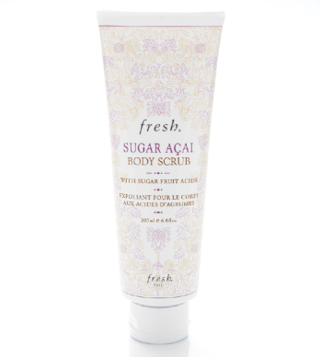

Smooth & Fruity

*Fresh-Sugar Acai Body Scrub*

No, we aren’t talking about a smoothie, but the Sugar Acai Body Scrub by *Fresh*, the destination for everything you need for beauty. The product’s fruit acids act help restore, exfoliate and renew your skin. The sugar crystals sweep away dead skin cells and when combined, the result is smoother, softer and younger looking skin. While no one will complain about your delicious smell, they may ask what the scent is. Therefore, simply state with ease “bergamot, caramel and acai oil (otherwise known as the Brazilian super-berry), not only will you smell delectable, but it shows you know your stuff! Pair the Sugar Acai Body Scrub with Sugar Acai Age-Delay Body Cream and be “super berryliscious, but be warned, you may have to push people away.

Being *Fresh* in New York is no problem:

1367 Third Avenue  
*corner of 78th St and Third Ave*

872 Broadway  
*corner of Broadway and 18th St*

159 Columbus Avenue  
*corner of Columbus and 67th St*

**Fashion**

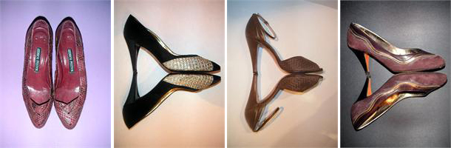

Move Over Diamonds…Shoes Are Really a Girl’s Best Friend

*Girls Love Shoes*

The perfect name for a store because girls really do love shoes. Located at 29 Ludlow Street in New York’s Lower East Side, the shop is both a vintage shoe rental and boutique. Owned by Zia and Dana Ziprin, Girls Love Shoes, established in honor of their mother, Joanne Ziprin, reflects the influence of vintage shoes, clothing and accessories and demonstrates their creative and ambitious endeavors in the world of fashion. GLS has carries all types of shoes, flats, high heels, sandals, mules, pumps, sling backs, slides, slippers and boots. The boutique contains approximately 300 pairs of shoes all of assorted styles and colors. The shoe archive houses over 3,000 pairs of shoes from the 1800s to the early 1990’s and even top shoe designers use the archive as inspiration. Some of the shoes are so fabulous, that the GLS shoe archive can be viewed by appointment only. Diamonds may be forever, but shoes are pretty wonderful too.

To be in shoe heaven:

GLS Boutique: 29 Ludlow St., New York, NY, 10002

*corner of Hester*

Rental Archive: 85 Hester St.

*between Orchard & Allen*

**Food**

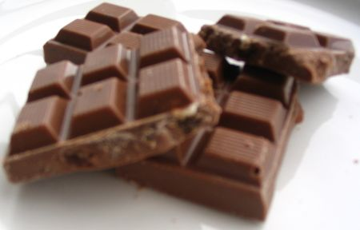

For the Love of Chocolate

*Have Some Chocolate, Courtesy of Max Brenner (The Bald Man)*

“Chocolate is not just about taste” and Max Brenner, Chocolate by the Bald Man, demonstrates this by creating its own chocolate culture for everyone to indulge in. Founder and owner Max Brenner has truly created a new chocolate culture and it should not be missed. The restaurant/café/chocolate shop, is truly a chocolate lovers paradise! The moment you walk into Max Brenner, you come face to face with chocolate and more chocolate. To Max Brenner, chocolate is more than just food, it’s about emotions; romance, relaxation, indulgence, imagination. Max Brenner’s serves a variety of chocolaty delights and creations, such as the Hug Mug (delicious, thick, hot chocolate), chocolate cocktails and smoothies, chocolate pizza, chocolate fondue (great for dipping strawberries) and pretty much anything else you can think of that has to do with chocolate. This is a culture you may want to partake in, even if it’s just once. It seems this is the stuff dreams are made of.

Fulfill your chocolate craving:

841 Broadway (*between 13th & 14th Streets)*

141 Second Avenue (*at 9th Street)*

*www.maxbrenner.com*

**Lifestyle**

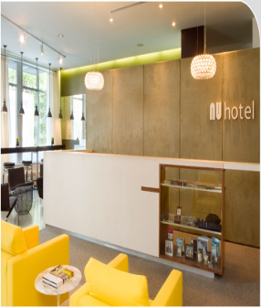

Experience Something Nu: Boutique in Brooklyn

*Nu Hotel in Downtown Brooklyn*

The Nu Hotel is the first boutique hotel in downtown Brooklyn, plus it is eco-friendly. The atmosphere at the Nu Hotel is simple, clean, smart and casual. The Hotel’s rooms are loft-inspired and contain natural design elements, such as cork floors, lead free paint, organic sheets, biking and storage facilities. Their Urban Suite has an alcove king-sized bed and a sitting area, which includes a relaxing hammock. A unique feature of the Nu Hotel is the bathrooms contain chalkboard walls for writing down notes to others or whatever is going on in your head, plus Aveda bath products are provided for all guests. The Nu Hotel has complimentary WiFi access throughout the building, 32 inch flat screen televisions and a state of the art satellite music system. There is a 24-hour fitness center and the Nu Bar serves a continental breakfast and in the evenings is a full service bar that serves tapas. Located at the cross-roads of four amazing Brooklyn neighborhoods; Downtown Brooklyn, Boerum Hills, Cobble Hill and Carroll Gardens and only two subway stops from Lower Manhattan, the Nu Hotel is in a prime location because there is plenty to do if you want to venture outside and do some exploring. The area surrounding the Nu Hotel is filled with great places to dine, shop and have some fun! Your stay at the Nu Hotel is sure to be exciting, but at the same time soothing and inspiring. You may just forget where you are.

Experience something Nu:

85 Smith Street, Brooklyn